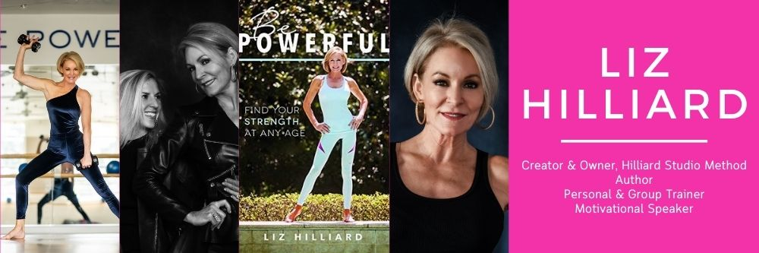
“Be Powerful.”
Liz Hilliard, author, motivational speaker, personal & group trainer, and owner & creator of Hilliard Studio Method (HSM) – an internationally-renowned, core-centric, Pilates-based workout that uses the latest techniques to get the heart rate pumping and sweat dripping – uses that mantra daily to empower and encourage women of all generations and fitness levels to accept themselves as they are and keep moving.
Since 2007, followers around the world have changed the way they look and feel by using her unique, proven, and unparalleled Method. Described as “Pilates on steroids,” HSM is a core-centric, total-body workout that is both safe and effective. An entrepreneur and business owner who established HSM in her 50s, Liz helps women at any stage of life sculpt strong, healthy, beautiful bodies and minds while inspiring clients of all ages to chase their dreams by fostering an inclusive, welcoming community.
Available in all 50 states as well as internationally with an online streaming platform, live Zoom classes, and fully stocked wellness boutique out of the flagship studio in Charlotte, NC, the HSM brand continues to grow and evolve and now includes the wildly popular Hilliard Studio Podcast, which she co-hosts with HSM Director of Training, Lee Kennelly.
Liz’s first book, Be Powerful: Find Your Strength at Any Age is not only the story of how she created her signature Method, but also how she found the strength to overcome one of her most challenging life events and inspires others to find their authentic and most powerful selves. Her book tour and speaking engagements have taken Liz to a level of national recognition, speaking at corporate executive events hosted by Bank of America, Wells Fargo, and Neiman Marcus Charlotte.
Liz has served as keynote speaker of Wells Fargo Executive Women in Business events, and as an expert panelist on various national stages, including BrandShop events in Charlotte and New Orleans, an event featuring The Class by Taryn Toomey, as well as hosting a recurring wellness series of seminars at her flagship studio in Charlotte.
Additionally, Liz has made a host of media appearances over the years and been featured in numerous national publications including Yahoo! Lifestyle, Oxygen Magazine, Healthy Advantage, Self, and Huffington Post.
Under Liz’s guidance, HSM has evolved into a diverse and accessible three-part platform that allows clients to access the magic of Hilliard Studio Method anytime and anywhere. The flagship studio hosts HSM In Person classes seven days a week in Charlotte. The HSM On Demand video subscription service houses over 10,000 minutes of video that can be streamed via app and any device for affordable and easy access while the growing pandemic pivot HSM Stream Studio gives clients an in-studio feel from anywhere in the world. The retail shop boasts branded and other top-of-the-line apparel lines, partnerships with lifestyle and wellness products, as well as the HSM Signature Smoothie.
Liz was the recipient of the SmartCEO Charlotte Corporate Culture Award and voted one of Charlotte’s 50 Most Influential Women. She understands that being an entrepreneur doesn’t result in immediate success, and that failure and rejection come with growth. “I learned early to handle success and failure with an even hand. I honor my failures and learn from them. Failure is not fatal, and success is not final.”
A walking testament to her Method and mantra, Liz reaches deep into the souls of her audience with great passion and energy to help each of them achieve their fitness, overall wellness, and lifestyle goals. Come to class, stream Hilliard Studio Method workouts from anywhere in the world, read Liz’s message within the pages of her book, and experience her engaging and positive energy to become your healthiest, most POWERFUL self!

